EXPERIMENT-2 .
- AIM:
To design and implement an end-to-end ETL (Extract, Transform, Load) pipeline using Microsoft Power BI's Power Query Editor, enabling the extraction of data from a real-world business dataset, application of transformation logic, and loading of cleansed data into a unified analytical model for reporting and decision-making.

- OBJECTIVES:
- To understand the ETL process and its role in Business Intelligence.
- To create relationships between multiple tables in the Power BI data model.
- To prepare the transformed data for reporting and business analysis.

- TOOLS / SOFTWARE REQUIRED:
- Microsoft Power BI Desktop
- Global Superstore Dataset.xlsx
- Power Query Editor – built into Power BI Desktop
- DAX (Data Analysis Expressions)

- DATASET USED: Global Superstore Dataset.xlsx.

- THEORY:
ETL (Extract, Transform, Load) is an important process in Business Intelligence that helps convert raw data into a clean and usable form for analysis. It consists of three major stages. Extraction is the process of collecting data from different sources such as databases, Excel files, CSV files, cloud applications, and other external systems. Transformation involves preparing the extracted data by removing duplicate and unnecessary records, handling missing values, correcting data types, standardizing inconsistent information, renaming columns, creating calculated fields, and combining data from multiple sources. Loading is the final stage, in which the transformed data is transferred to a centralized system such as a data warehouse or a BI data model for reporting and analysis. In Microsoft Power BI, ETL operations are mainly carried out using Power Query Editor. It provides various tools for filtering, sorting, merging, appending, and modifying datasets without changing the original source data. Power Query also maintains a record of every transformation under Applied Steps, making the complete data preparation process easy to track, review, and reproduce. Thus, ETL ensures that the data used for Power BI reports and dashboards is accurate, consistent, organized, and suitable for analysis.

- PROCEDURE:

A. Extract – Importing the Dataset
Step 1: Download Global Superstore Dataset.xlsx and save it in the experiment folder. Open Power BI Desktop and select Home > Get Data > Excel Workbook to locate and open the file.
Step 2: In the Navigator window, select the Orders, Returns, and People worksheets. Choose Transform Data so that the selected tables open in Power Query Editor. Verify that all three tables are visible in the Queries pane.

B. Transform – Cleaning and Preparing the Data
Step 3: Select the Orders table and inspect its contents. Remove duplicate records and blank rows, correct inappropriate data types, and rename unclear column headings where required.
Step 4: Prepare the important fields in the Orders table. Extract Year and Month from Order Date, create a Profit Margin column, and make the values in Region and Segment consistent. Review the Applied Steps section to check the transformations.
Step 5: Select the Returns table and clean the data by checking duplicate Order IDs, missing values, and inconsistent entries in the Returned column. Similarly, inspect the People table, remove unnecessary columns, and ensure that the Region names are consistent with the Orders data.
Step 6: Combine the required information from Orders and Returns by using Order ID as the matching field. Select Merge Queries, choose the Returns table, match the Order ID columns, select the suitable join option, and apply the merge.
Step 7: Review all three queries and their Applied Steps to ensure that the required cleaning and transformation operations have been completed. Select Home > Close & Apply to load the prepared data into Power BI.

C. Load – Data Modeling and Analysis
Step 8: Open Model View and establish the required relationships between the tables. Connect Orders with Returns using Order ID and Orders with People using Region. Check the relationship lines and ensure that the model is connected correctly.
Step 9: Create the required DAX measures in the Orders table using New Measure:
- Total Sales = SUM(Orders[Sales])

- Total Profit = SUM(Orders[Profit])

- Profit Margin = DIVIDE(SUM(Orders[Profit]), SUM(Orders[Sales]))

- Total Orders = DISTINCTCOUNT(Orders[Order ID])
These measures are used to calculate the main performance indicators for the report.

D. Report Creation and Visualization
Step 10: Create the final Power BI report using the transformed data and DAX measures. Add Card visuals for Total Sales, Total Profit, Profit Margin, and Total Orders.
Step 11: Add suitable visualizations to analyze the business data, including a Sales by Category bar chart, Profit by Category pie chart, Profit Margin vs. Discount scatter chart, and a Sales & Profit Analysis table.
Step 12: Arrange the visuals into a clear dashboard layout and give the report the title “GLOBAL SUPERSTORE – ETL & SALES ANALYSIS.” Finally, check the visuals, relationships, and calculated measures to ensure that the report displays the expected results.
- RESULT
The Global Superstore data was successfully imported, cleaned, transformed, and loaded into the Power BI data model. The required data preparation tasks, including removing inconsistencies, standardizing values, creating table relationships, and defining DAX measures, were completed successfully. The resulting data model is now organized and ready to be used for report generation, visualization, and business analysis.
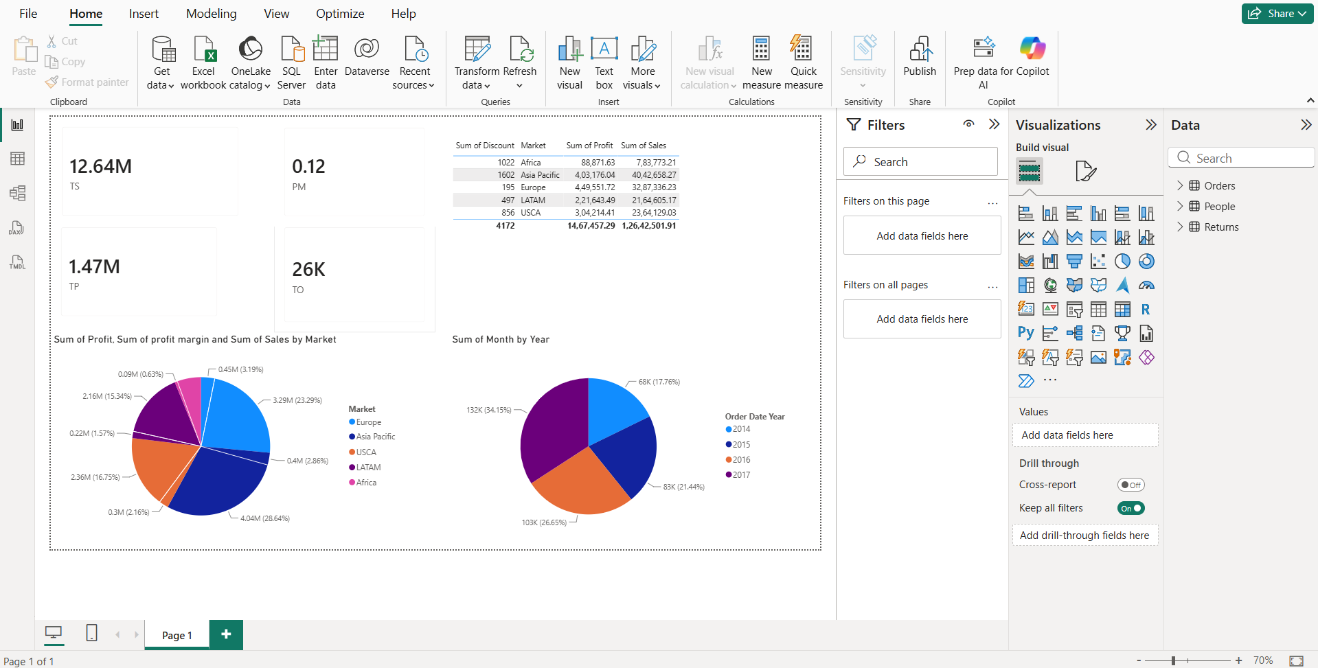

- LEARNING OUTCOMES
- Understood the ETL process and its role in Business Intelligence.
- Learned how to handle duplicate records, blank values, and data type inconsistencies.
- Understood the use of Total Sales, Total Profit, Profit Margin, and Total Orders measures.
- Learned how to create BI visualizations and dashboards for business analysis.
- Gained practical experience in preparing transformed data for reporting and decision-making.

